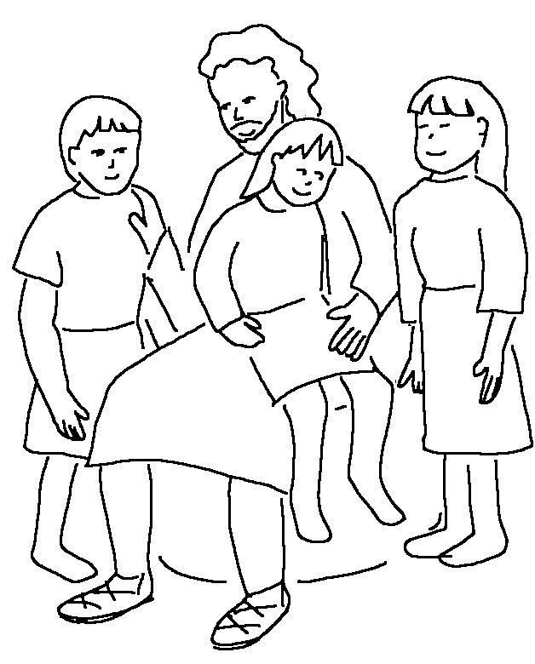

Dear friends, since God _ _ _ _ _ us that much,
we surely ought to love _ _ _ _ _ _ _ _ _. 1 John 4:11_{NLT}

